PS3 -Lab 7
Areesha Raheel
55039
BSIT_6
1. You are a mountain climber preparing for a high-altitude expedition. You have exactly 6 pieces of essential gear, each with a specific weight (in kg) and a benefit score (how useful it is for survival and performance). Your backpack has a strict weight limit of 15 kg. You can either take an item or leave it (no fractions allowed). Select the subset of items that maximizes the total benefit score without exceeding the weight limit.
Items:
- Compass: weight 2 kg, benefit 18
- Headlamp: weight 3 kg, benefit 25
- First-aid kit: weight 4 kg, benefit 30
- Energy bars: weight 5 kg, benefit 35
- Rope: weight 6 kg, benefit 40
- Emergency shelter: weight 7 kg, benefit 45
What is the maximum benefit you can achieve, and which items should you take?

0/1 Knapsack Problem (Mountain Climber Gear)
We need to maximize benefit without exceeding 15 kg.
Items
Item | Weight | Benefit
Compass | 2 | 18
Headlamp | 3 | 25
First-aid kit | 4 | 30
Energy bars | 5 | 35
Rope | 6 | 40
Emergency shelter | 7 | 45
Capacity = 15 kg

Best Combination Check
Try combinations near weight 15:
- Compass + Headlamp + First-aid + Energy bars
Weight = 2+3+4+5 = 14
Benefit = 18+25+30+35 = 108
- Compass + Headlamp + Rope + Emergency shelter
Weight = 2+3+6+7 = 18 ✗
- Headlamp + First-aid + Rope
Weight = 3+4+6 = 13
Benefit = 25+30+40 = 95
- First-aid + Energy bars + Rope
Weight = 4+5+6 = 15
Benefit = 30+35+40 = 105
- Compass + Headlamp + First-aid + Rope
Weight = 2+3+4+6 = 15
Benefit = 18+25+30+40 = 113 ✓
- Compass + Energy bars + Emergency shelter
Weight = 2+5+7 = 14
Benefit = 18+35+45 = 98
Maximum found = 113

Final Answer
Selected Items
- Compass
- Headlamp
- First-aid kit
- Rope
Total Weight
15 kg
Maximum Benefit
113
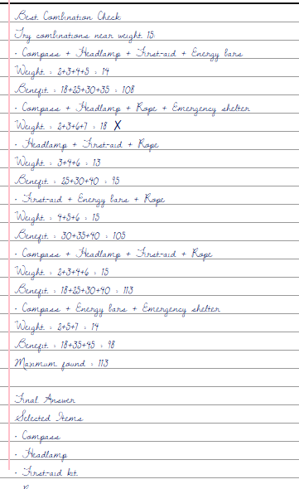

2. In a corporate espionage investigation, 7 key suspects (labeled P1 to P7) have been identified. Intelligence reports show which pairs have secretly met or collaborated (represented as undirected edges in a graph). A “clique of size 4” would be a group of 4 suspects where every pair has collaborated — indicating a tightly coordinated inner circle.
Determine whether a clique of size 4 exists.
Graph edges (undirected): P1–P2, P1–P3, P1–P4, P1–P5, P2–P3, P2–P4, P2–P6, P3–P4, P3–P5, P4–P6, P4–P7, P5–P6, P6–P7.
Does such a clique of 4 exist? (Answer yes/no and, if yes, name one such group.)
2. Clique of Size 4
A clique of size 4 means every member is connected to every other member.
Given Edges
P1–P2, P1–P3, P1–P4, P1–P5
P2–P3, P2–P4, P2–P6
P3–P4, P3–P5
P4–P6, P4–P7
P5–P6
P6–P7
Check group {P1, P2, P3, P4}
Required edges:
- P1–P2 ✓
- P1–P3 ✓
- P1–P4 ✓
- P2–P3 ✓
- P2–P4 ✓
- P3–P4 ✓
All exist.

Final Answer
Yes, a clique of size 4 exists.
One such clique:
{P1, P2, P3, P4}

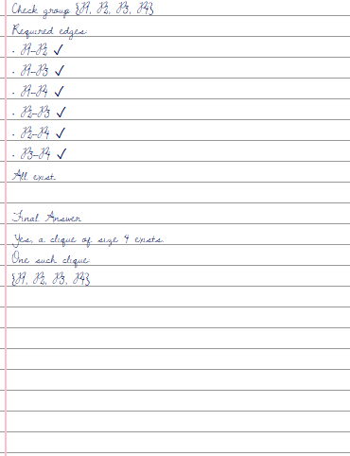
3. A logistics manager must load exactly 42 kg of specialized cargo using only whole crates from the available inventory. The crates have the following weights (in kg): {4, 7, 9, 11, 13, 16, 18, 22}. You cannot split any crate.
Is it possible to select a subset of these crates whose weights sum exactly to 42 kg? If yes, provide one such subset; if no, explain why it is impossible.
3. Subset Sum Problem
Find subset from:
{4, 7, 9, 11, 13, 16, 18, 22}
such that sum = 42.

Try combinations:
- 22 + 16 + 4 = 42
Final Answer
Yes, it is possible.
One valid subset:
{22, 16, 4}
Sum:
22 + 16 + 4 = 42

4. A university department must schedule 6 elective courses (C1 to C6) into time slots. Two courses cannot be held at the same time if they share students (shown as an edge). The goal is to find the minimum number of time slots (colors) needed so that no two conflicting courses are scheduled together.
Graph edges (undirected): C1–C2, C1–C3, C1–C4, C2–C3, C2–C5, C3–C4, C3–C6, C4–C5, C5–C6.
What is the chromatic number (minimum colors required)? Provide a valid coloring using that many colors (assign each course a color number) to prove it is possible.

4. Graph Coloring (Chromatic Number)
Vertices
C1, C2, C3, C4, C5, C6
Edges
C1–C2, C1–C3, C1–C4
C2–C3, C2–C5
C3–C4, C3–C6
C4–C5
C5–C6

Notice triangle:
- C1–C2
- C2–C3
- C1–C3
A triangle requires at least 3 colors.
Now test 3-coloring.
Valid Coloring
Course | Color
C1 | 1
C2 | 2
C3 | 3
C4 | 2
C5 | 1
C6 | 2
Check conflicts:
- C1–C2 → 1 vs 2 ✓
- C1–C3 → 1 vs 3 ✓
- C1–C4 → 1 vs 2 ✓
- C2–C3 → 2 vs 3 ✓
- C2–C5 → 2 vs 1 ✓
- C3–C4 → 3 vs 2 ✓
- C3–C6 → 3 vs 2 ✓
- C4–C5 → 2 vs 1 ✓
- C5–C6 → 1 vs 2 ✓
All valid.

Final Answer
Chromatic Number
3
Valid Coloring
- C1 → Color 1
- C2 → Color 2
- C3 → Color 3
- C4 → Color 2
- C5 → Color 1
- C6 → Color 2

5. You own a small printing press and have received 5 urgent print jobs. Each job takes exactly one full day to complete, and you can do only one job per day. Each job has a profit and a strict deadline (the latest day it can be finished). Any job finished after its deadline earns zero profit.
Determine the optimal sequence of jobs and the maximum total profit you can earn.
Jobs:
Job ID | Profit | Deadline (days)
J1 | 120 | 2
J2 | 90 | 1
J3 | 80 | 3
J4 | 70 | 2
J5 | 40 | 3

Which jobs should you schedule on which days, and what is the maximum profit?
5. Job Sequencing with Deadlines
Jobs Table
Job | Profit | Deadline
J1 | 120 | 2
J2 | 90 | 1
J3 | 80 | 3
J4 | 70 | 2
J5 | 40 | 3
Maximum deadline = 3
So we have slots: Day 1, Day 2, Day 3
Step 1: Sort by Profit
Job | Profit | Deadline
J1 | 120 | 2
J2 | 90 | 1
J3 | 80 | 3
J4 | 70 | 2
J5 | 40 | 3
Step 2: Schedule Jobs
J1 (deadline 2)
Place on Day 2
J2 (deadline 1)
Place on Day 1
J3 (deadline 3)
Place on Day 3
J4
No slot available before deadline 2
J5
No slot available
Final Schedule
Day | Job
1 | J2
2 | J1
3 | J3
Maximum Profit
90 + 120 + 80 = 290




